Strategy Overview:

The Sector Rotation investment program is a tactical long term growth strategy designed for capital appreciation. The strategy seeks sectors that are expected to outperform the S&P 500 Index in the upward market while investing is short term treasuries and sectors that are less correlated to S&P 500 in the volatile market. The investment process has three prongs, Market Outlook Model, ETF Selection model and Portfolio Construction and Risk Management.

Primary Objective:

Long Term Capital Appreciation in favorable market environment and Capital Preservation in volatile markets.

Investment Process:

The strategy switches from risk seeking outlook in a bullish market to risk averse in bearish market through a 3 step investment process.

1. Market Risk Model: The model assesses the risk tolerances in the equity markets and among the financial market participant and aims to minimize the volatility and drawdown of the portfolio in turbulent market environment.
2. Portfolio Construction: Sector ETF’s are analyzed and ranked based on the factors like risk, growth and persistence and ETF’s with highest risk adjusted ranks are included in the portfolio. Proprietary weighting scheme is utilized to construct the portfolio that switches gears between the risks seeking to risk averse portfolio and vice versa based on the market conditions.
3. Risk Management: The portfolio is rebalanced monthly and the risk is managed through the proprietary weighting scheme that suggest profit takes, position sizing and short term treasuries.

Risk Indicator vs S&P 500 Index

Risk Indicator vs S&P 500 Performance

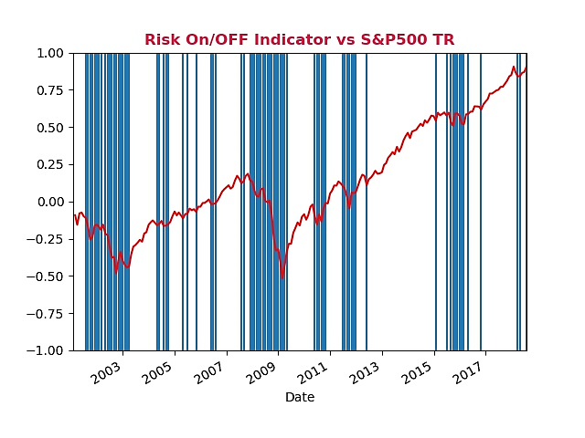

Historical Performance as of 07/31/2018

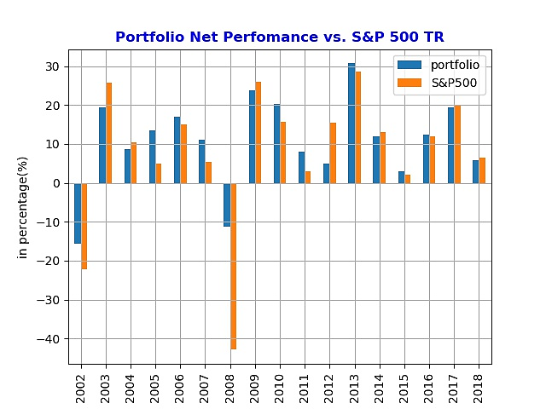

Historical Correlation vs S&P 500

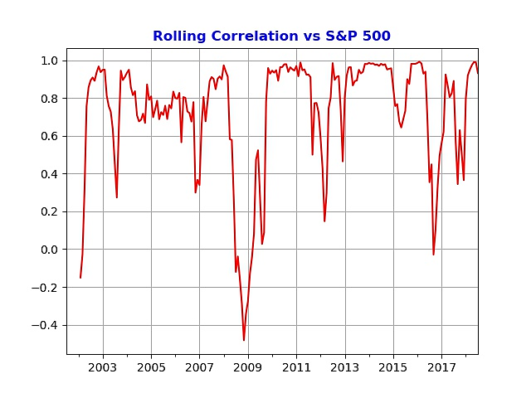

Equity Curve

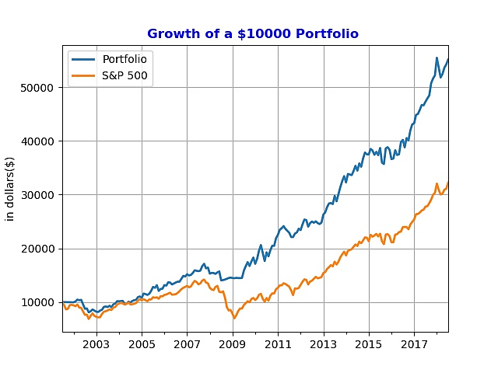

**Historical Draw Down:**

